**Thermal Hydraulics: In-Core – Landon Brockmeyer**

Design Approach:

The design of the geometry and composition of the core of this reactor is largely a function of thermal hydraulic considerations and neutronic considerations. Thermal hydraulic considerations include maximum temperatures of fuel, cladding and coolant, as well as pressure drop. Neutronic considerations primarily include fuel to coolant ratio. The neutronic considerations were prioritized over thermal hydraulic considerations in order to maximize lifetime of the core and to minimize leakage. As such, the fuel to coolant ratio was taken as a constraint for thermal hydraulic purposes. The volumetric heat generation rate was determined from the desired core thermal power production.

The first step in designing the core was to decide upon core materials. No member of the team involved in the design was designated to study material performance, so the materials chosen was based on a lose literature review. The reactor design detailed in this report is largely inspired by the General Atomics Energy Multiplier Module (EM2) reactor. The EM2 reactor uses Uranium Carbide as fuel, Silicone Carbide as cladding and helium as a coolant. Helium was the natural choice of coolant for this design. Other gasses such as nitrogen, carbon dioxide, or air have inferior cooling properties. Another popular coolant for fast reactors is liquid sodium; however, the sodium is extremely corrosive and not conducive to the long fuel element lifetime desired for this reactor. Silicon Carbide was chosen as cladding for its promising longevity and resistance to corrosion. Uranium Carbide was chosen as fuel for its high melting point and superior heat transfer properties.

The basic geometry was chosen next. Two common geometries for fast reactors are fuel rods, fuel plates, and fuel pebbles. Fuel pebbles were not considered or modeled. The key advantage of fuel pebbles is there ease of refueling, which is unnecessary for our design. Fuel rods and fuel plates were initially considered. After initial analytical modeling, fuel plates were chosen. Fuel plates have the advantage of thermally decoupling subchannels, resulting in higher accident tolerance, as one faulty channel does not cascade into multiple faulty channels. Fuel plates result in more consistent and even cooling, along with higher surface are to volume ratio. Fuel plates are more easily modeled, and are thus easier to design and optimize. Helium in combination with the coolant channels results in the added benefit of hot channels naturally cooling better due to the strong buoyant forces of helium and the chimney effect created by the channels.

To begin designing the core configuration, an analytical model was created. An analytical model of the reactor can easily be permuted to find a variety of possible configurations from which to narrow down on a final design. The analytical model was created using Microsoft Excel. A single channel was specified including fuel thickness, flow channel thickness, pressure, and inlet mass flow rate. Heat generation rate and fuel to cladding ratio are constrained by neutronics. Inlet and outlet bulk fluid temperatures are constrained by the power cycle thermal hydraulics. Maximum fuel and cladding temperature and cladding thickness are constrained by materials. Material properties such as viscosity, density, heat capacity, and thermal conductivity were determined as a function of temperature and pressure were determined by empirical correlations. The heat transfer coefficient was estimated using the Seider Tate correlation. The channel was discretized into 300 axial segments. The fluid temperature of each segment is a function of the properties of the previous segment and the heat transfer from the cladding. The cladding and fuel temperatures were then calculated using a heat transfer equation. For simplicity, the axial heat flux distribution was taken to be uniform. Using this method an average channel and hot channel were modeled. Using this analytical model, a variety of configurations that fit the listed constraints were found. From these configurations, a final candidate was selected for CFD modeling based on minimizing pressure drop and maximizing fuel to coolant ratio.

With a fuel design candidate found, CFD modeling was performed on a single channel to ensure that the fluid behaved as expected, and to optimize the geometry. The CFD modeling was performed with STARCCM+. The fluid was modeled using a Reynolds Averaged Navier Stokes (RANS) two equation realized k-ε with two-layer wall treatment. The helium was assumed to be an ideal gas. Material properties were estimated using the same empirical correlations as the analytical model.

The geometry of the cladding interface with the helium was then permuted to increase mixing. The increase in mixing comes at the expense of pressure drop. A variety of geometries were modeled including a flat surface, ribs, and dimples.

With the final geometry modeled with a variety of surfaces, a final fuel design was chosen. The pressure drop and temperature change for this fuel design were then passed on to the system designer for optimization of the power cycle of this reactor.

Design Results.

The analytical model was created with the following restraints set:

* Maximum Fuel Temperature: 2000 K
* Maximum Clad Temperature: 1600 K
* Bulk Fluid Temperature In: 850 K
* Bulk Fluid Temperature Out: 1150 K
* Cladding Thickness: 1.1 mm
* Fuel to Coolant Ratio: ~2.8
* Average Fuel Power: 100 W/cm3
* Hot Channel Fuel Power: 200 W/cm3

The parameters changed included:

* Pressure
* Fuel Thickness
* Channel Thickness
* Inlet Velocity

Several configurations satisfied these conditions. The configuration estimated to have the lowest pressure drop was chosen as the candidate geometry to be modeled. The candidate geometry had the following parameters:

* Pressure: 15 MPa
* Fuel Thickness: 1 cm
* Channel Thickness: 3.5 mm
* Inlet Velocity 70 m/s

The predicted temperature profile for the average subchannel is shown in Figure X.1. The leftmost point is the fuel centerline temperature, the next pint is the fuel outer temperature, followed by the inner cladding, outer cladding, and average fluid temperature. The temperature profile is shown for 4 axial heights.

Figure X.1. Average Channel Temperature Distribution, Analytical

The temperature profile is very flat compared to other reactors including existing LWRs. This flat profile means a low temperature gradient which is better for material structural integrity. It also demonstrates that this configuration is good for conducting energy out of the fuel and into the coolant. Temperature gradients are quickly flattened in this design. The increase in temperature through the core is nearly linear throughout.

The predicted temperature for a hot subchannel is shown in Figure X.2.

Figure X.2. Hot Channel Temperature Distribution, Analytical

Again the temperature distribution is noticeably flat, however not as flat as the average channel. The fuel especially is excellent at conducting heat, making Uranium Carbonate very accident tolerant. Even in the hot channel the fuel is over 400 K from reaching unacceptable temperatures. The cladding is the first to fail in this design. This reactor is in many ways limited by material considerations.

With the geometry candidate chosen and according to the analytical calculations capable of meeting the design needs, a further CFD investigation was carried out. The initial CFD run was actually for a previous iterations geometry. However, it revealed a design problem that needed to be resolved. The smooth walls of the initial design resulted in poor mixing of the coolant, and thus severe temperature gradients between the near wall coolant and the channel center coolant. The cladding walls needed a geometry change to encourage mixing. This mixing comes at the expense of pressure drop. Thus a variety of geometries were tested to modeled to increase mixing. Two ribbed designs and a dimpled design were compared to the flat wall design. For each design the features were separated vertically by 5 mm. One ribbed design featured a 1 mm diameter rib, and the other a 0.5 mm diameter rib. The dimples were vertically and horizontally 5 mm apart and 0.5 mm in diameter. Figure X.3 shows close up images of the three configurations.

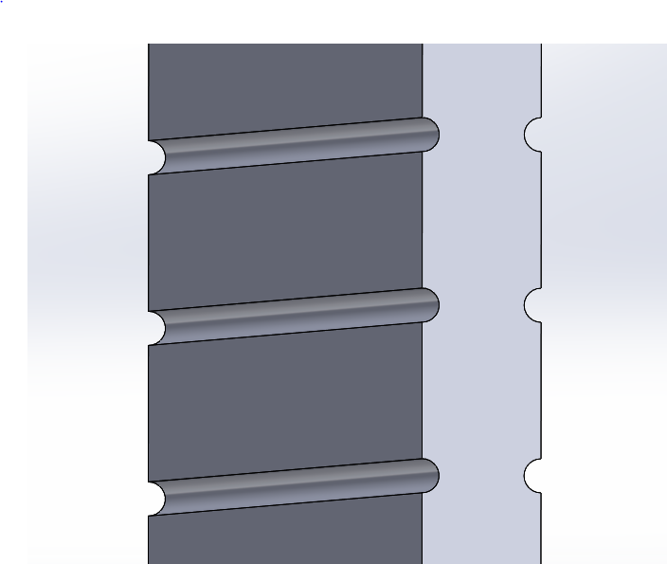 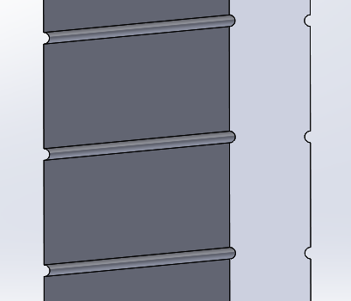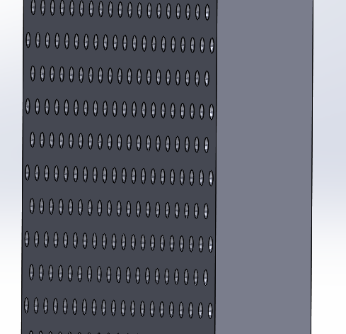

Figure X.3. Wall Features from Left to Right: 1 mm Ribs, 0.5 mm Ribs, 0.5 mm Dimples.

The exiting temperature profiles of each design is shown in Figure X.4.

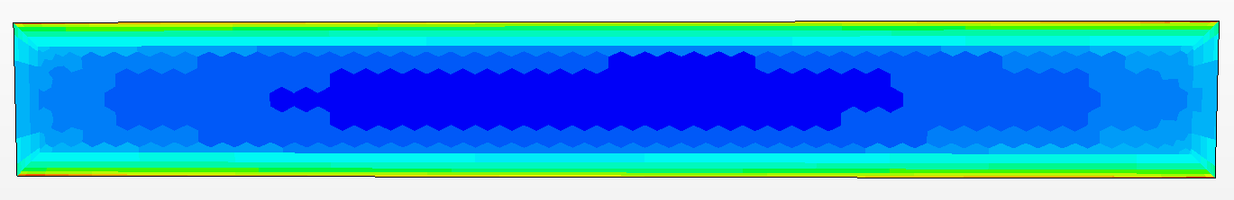

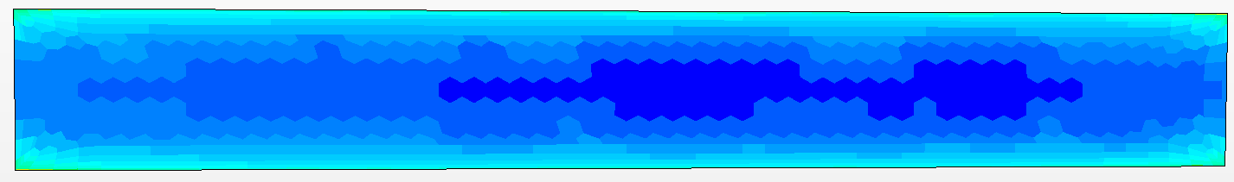





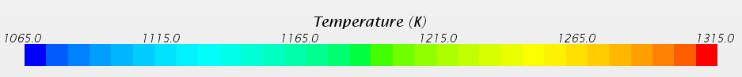

Figure X.4. Exit Temperature Profiles From Top to Bottom: Flat, 1 mm Ribs, 0.5 mm Ribs, 0.5 mm Dimples, Temperature Key.

The flat walls are clearly inferior to the other wall designs. The 0.5 mm Ribs had the best temperature mixing. The dimpled design had the lowest pressure drop. However, the dimpled design had much greater wall temperature discrepancies whereas the ribbed design had much flatter wall temperatures, despite slight increases below and above the ribs. Based on this the smaller diameter ribs were seen as the superior model.

For the final geometry CFD investigation, because the geometry changed, another wall study was carried out. Only two designs were investigated. The channel for this design was much narrower. The first design featured 1 mm ribs spaced 5 mm apart, the second 0.5 mm ribs spaced 5 mm apart. Both designs had comparable temperature profiles, differing only slightly. However, the design with the larger ribs suffered greatly for pressure drop, reaching 3.7 MPa, which is prohibitively high. The 0.5 mm rib designs pressure drop was only 710 kPa, while high, is manageable. The outlet temperature profile as well as near exit wall temperature profile is shown in Figure X.5.



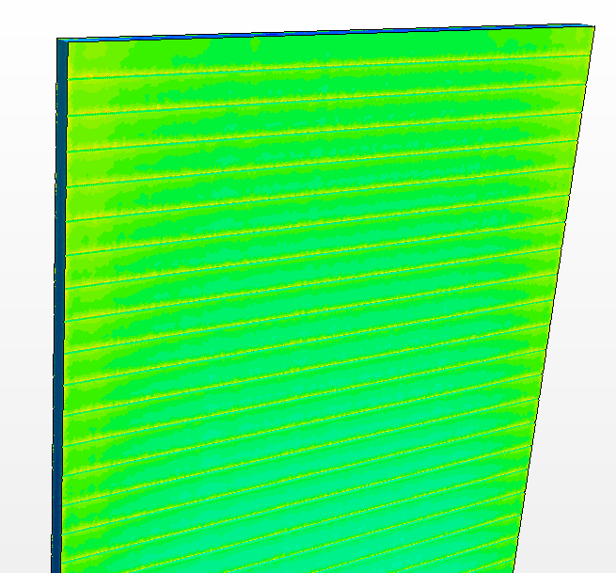

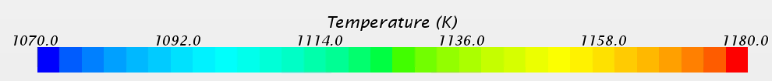

Figure X.5. Final Design Exit and Top Wall Temperature Profiles.

The outlet Temperature profile is extremely flat. Additional CFD analysis should be made to see if smaller ribs could result in a flat exit temperature while further reducing pressure drop. Small increases in temperature can be seen above each of the ribs. This is to be expected as the flow stagnates slightly here. This, however is inconsequential, as the temperature increase is far below a level of concern. Smaller ribs may result in even flatter wall temperature distributions. Additionally, the exit temperature profile could be flattened additionally by curving the outside corners. The peak temperature occurs in these corners and could be reduced. Until further wall designs are studied, this design can be considered successful for meeting the design criteria.

Natural convection in the case of loss of power is an important aspect of this design. This portion of the design could not be modeled in the time available. However, this design is promising for natural convection being an option for emergency cooling. In the event that the reactor must be shut down and pressure in maintained, similar designs to this are fully capable of being cooled by natural convection alone. The cooling channels form nice chimneys for the helium to circulate. The high thermal expansion of helium and the large vertical temperature gradient indicates that the reactor would have a high natural convection cooling coefficient. In the case of loss of pressure however, then density of the helium decreases by a factor of 10. In this case, natural convection can no longer provide sufficient cooling. Forced convection in the form of battery powered fans are necessary for about 3 days before natural convection is sufficient to cool the core on its own. This reactor should feature a dedicated natural convection decay heat removal loop as shown in Figure X.6.

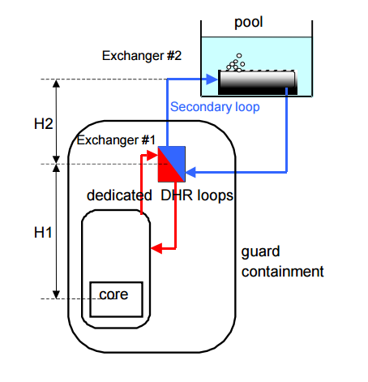

Figure X.6. Example of Dedicated Natural Convection Decay Heat Removal Loop.

Conclusion:

The in-core geometry is governed by neutronic and thermal-hydraulic considerations. A high fuel to coolant ratio is necessary for this helium cooled fast reactor. A geometry that meets the material, neutronic, and power cycle criteria was found with an analytical model and observed further with CFD analysis. The final geometry can is described by the following parameters:

* Bulk Fluid Temperature In: 850 K
* Bulk Fluid Temperature Out: 1150 K
* Cladding Thickness: 1.1 mm
* Pressure: 15 MPa
* Fuel Thickness: 1 cm
* Channel Thickness: 3.5 mm
* Inlet Velocity 70 m/s
* Fuel to Coolant Ratio: ~2.8
* Average Fuel Power: 100 W/cm3
* Hot Channel Fuel Power: 200 W/cm3
* Thermal Power: 623 MW
* Pressure Drop: ~700 kPa
* Wall Rib Diameter: 0.5 mm
* Wall Rib Spacing: 5 mm

The design has an exceptionally flat temperature profile, and exceptionally even exit temperature distribution, which reduces material stressed in the system, and reduced temperature driven complications e.g. thermal striping. The design is conducive to natural convection and with further analysis could be shown to have much desired passive safety features. The pressure drop is higher than desirable, but within a reasonable amount. This could be reduced with further analysis into wall ribs.

**Design Basis Accident – Landon Brockmeyer**

A common design basis accident is a loss of coolant accident. In the case of this reactor, a possible worst case scenario would be loss of coolant, loss of onsite power, and loss of pressure accident, which could conceivably all happen at once. In this case the natural convection passive cooling system would not suffice. With a loss in pressure the helium decreases in density by an order of magnitude. If the helium inventory completely escapes, then air would be the coolant with even worse natural convection capabilities. While such an analysis couldn’t be conducted for this report, a natural convection analysis of this reactor for common air could be conducted for a variety of heat fluxes to determine at what point natural convection of air could cool the reactor after shut down. The natural convection loop should be designed such that such cooling would be sufficient in under 3 days. A redundant set of battery powered fans can be expected to provide forced convection for up to 76 hours. Such fans add relatively little to the reactor cost, and are easily tested, and are extremely resistant to failure due to their simplicity. Depending on the height of the natural convection chimney necessary, this loop could add from a relatively low cost, to a high cost due to an increase in containment vessel size. This reactor design is much more resilient to such an accident than existing reactors which in all cases rely on expensive, and more prone to failure diesel generators. For most accidents no active intervention is necessary as passive cooling can suffice. Only in worst case scenarios would the active cooling system be necessary, and even then it is much simpler and more reliable than existing systems.